IOT Virtual Doctor Robot

Doctors are usually needed to work at every hospital and emergency centre every now and then. But it is not feasible for every doctor to be available at every place at desired time. The problem with video calling is that video calls need to be done from a PC or laptop on a desk. This limits the doctors capacity to view patient or around operation theatre at will or even move through hospital rooms as needed.
To help solve this issue we here develop a virtual doctor robot that allows a doctor to virtually move around at a remote location at will and even talk to people at remote location as desired. This robot provides a whole lot of advantages for doctors:
- Doctors ability to be at anyplace anytime
- Doctors can move around in operation theatres
- Doctors can move around the patient with ease
- Doctors can see medical reports remotely via video calls
- Doctors can move around in other rooms at will
The system makes use of a robotic vehicle with 4 wheel drive for easy navigation. The robot also includes a controller box for circuitry and a mounting to hold a mobile phone or tablet. The mobile or tablet is used to hold live video calls.
The doctor can use an IOT based panel to control the robot. The control commands sent sent online are received by the robot controller. The robot controller operates over wifi internet. The received commands are received in real time and the robot motors are operated to achieve the desired movement commands. Also the root has other functions including battery status alert to remind of battery charging on time.

Components:
- DC Motor
- Gearboxs
- Wifi Module
- Robotic Base Frame
- Wheels
- Shaft
- Pole Rod
- IC’s and IC Holders
- Resistors
- Capacitors
- Diodes and Transistors
- Antenna
- Switch and electrical Wiring
- Base Frame
- Supporting Frame
- Mounts an joints
- Screws and Bolts
Applications:
- Hospitals & Clinics
- Emergency Centers
Advantages:
- Doctors ability to be at anyplace anytime
- Doctors can move around in operation theatres
- Doctors can move around the patient with ease
- Doctors can see medical reports remotely via video calls
- Doctors can move around in other rooms at will
Disadvantages:
- Requires Battery Charging
- Need to attach a Tab or Mobile Phone

Block Diagram:
Front View
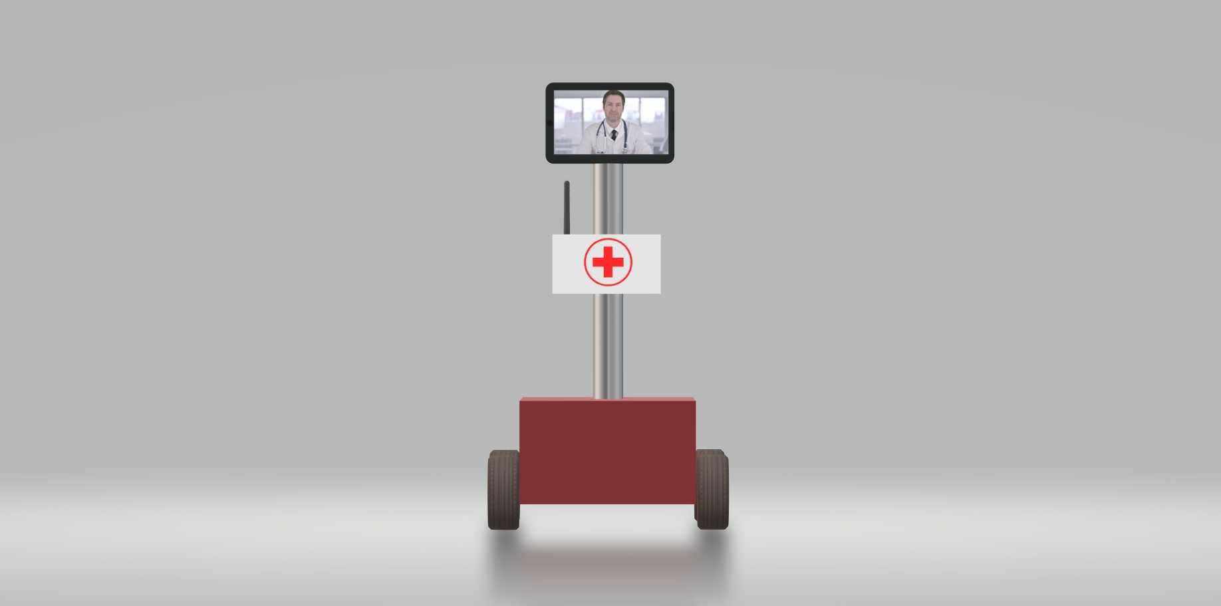

Side View
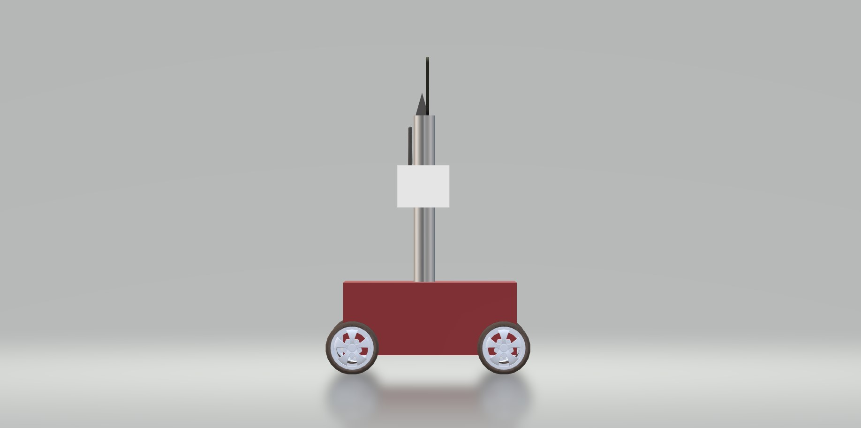

3D Views
